**FACULTY OF SCIENCE, ENGINEERING AND COMPUTING**

**School of Computer Science and Mathematics**

**MSc in Data Science**

**Author**

Darpan Sanjay Agarwal - K2279745

**Project Title**

Company Bankruptcy Predictions

**Supervisor**

Prof. Nebel, Jean-Christophe A

**Kingston University London**

**TABLE OF CONTENTS**

ABSTRACT 3

INTRODUCTION 4

OBJECTIVES 6

LITERATURE REVIEW 7

DATASET CONSIDERED 12

METHODOLOGY 12

SCHEDULE 15

RESOURCES AND BUDGET 16

ETHICS, AND DATA PROTECTION 16

REFERENCES 17

**ABSTRACT**

One of the most critical concerns in the finance field revolves around accurately predicting an organization's financial health in the future. In today's economic climate, most organizations place great importance on financial forecasting to ensure their survival and potentially avoid bankruptcy. The ability to predict bankruptcy is vital for decision-making, as it helps assess a company's solvency and its capacity to meet financial obligations.

Machine Learning techniques, particularly Deep Learning (DL) methods, have gained significant attention and have proven to be reliable indicators in financial applications, including bankruptcy prediction. In our research, we have chosen to adopt Deep Learning methods due to their effectiveness in classification tasks. Our study will compare three commonly used Deep Learning techniques those are Multilayer Perceptron model with six layers (MLP-6L), Long-Short Term Memory (LSTM), and the Deep Belief Network (DBN).

Additionally, to enhance the robustness of our predictions, we plan to leverage three ensemble classifier techniques which are K-Nearest Neighbor (KNN), Support Vector Machine (SVM), and Random Forest (RF).

A significant challenge we face is dealing with a severely imbalanced dataset. To mitigate this issue and achieve more reliable results, we will apply appropriate balancing techniques during our analysis.

As the field of machine learning continuously evolves, we want to explore new methods, especially in Artificial Neural Network (ANN) approaches.

To address the challenges even more effectively, we are intrigued by hybrid algorithms, which have shown promise in improving accuracy. Among these is the relatively newer MOA-PSO method, which we intend to implement and compare against our established Deep Learning methods to assess their respective performances.

**INTRODUCTION**

The issue of forecasting bankruptcy has garnered attention from researchers since the 1929 stock market crash as described by authors *Bellovary, Giacomino and Akers (2007)*. The repercussions of bankruptcy for a company carry significant weight, impacting a wide range of stakeholders, including employees, creditors, suppliers, and even entire nations. In the financial industry, researchers have been increasingly drawn to the field of technology such as machine learning (ML) and more particularly newer advancements in Deep Learning (DL). Increasingly, organizations are keen on acquiring this crucial analytical information. Nonetheless, the data concerning a company's financial health inherently exhibits an imbalance, as real-life bankruptcies are relatively rare as discussed by *Veganzones and Séverin (2018)*. Numerous types of research have concentrated on rectifying the lack of patterns within smaller dataset classes, such as companies being bankrupt in our scenario, which significantly impairs classifier performance and reliability. This is because these methods tend to prioritize modeling the majority class. Consequently, a variety of techniques have been used to tackle this issue, each employing its own criteria for data balance. We have carefully considered the most suitable and relevant techniques and implemented them in our analysis of financial data.

This paper seeks to take a more advanced approach by utilizing sophisticated classification methods to enhance prior outcomes. To achieve this goal, we have explored Deep Learning (DL) techniques by author *Schmidhuber (2015)* and upcoming artificial neural network models. DL, a subset of Machine Learning (ML), has demonstrated remarkable success in numerous applications, particularly those involving big data, surpassing the performance of traditional ML algorithms. We have opted for these advanced classification methods due to their established track record of delivering superior results when applied to financial data.

Hence, this research has examined several Deep Learning (DL) techniques, that includes Long-Short Term Memory (LSTM) described in brief by authors *Hochreiter and Schmidhuber (1997)*, a Multilayer Perceptron model with 6 layers (MLP-6L) by authors *Kasgari, Divsalar, Javid and Ebrahimian (2013)*, and authors Hinton, Osindero and The (2006) describe Deep Belief Network (DBN) in very comprehensive detail, for the purpose of predicting corporate financial distress. Additionally, we have implemented three ensemble methods based on a technique called “Bagging” which is briefed by author *Breiman (1996)*, namely Random Forest (RF) *Breiman* (2001), K-Nearest Neighbor (KNN) by authors *Cover and Hart (1967)* and authors *Cortes and Vapnik (1995)* describe Support Vector Machine (SVM).

Hence, each of the chosen DL classifiers falls into a distinct category of neural networks, with the intention of comprehensively exploring in diverse manners. Specifically, MLP-6L represents a neural network that works in a feed-forward way, LSTM is categorized as a recurrent neural network, and Deep Believe Network is characterized as a neural network that learns greedily, consisting of directed and undirected layers. Conversely, to enhance the performance of SVM and KNN, we treat them as ensemble models employing the bagging technique. Meanwhile, RF functions as an ensemble of decision trees based on bagging.

Typically, balancing of data can be achieved through one of the following approaches: Oversampling, Clustering-based techniques, and Hybrid Oversampling-Undersampling. Consequently, the methods chosen for this research encompass all three of these data preparation strategies to assess their impact on the performance of classifiers. The objective is to ultimately determine the most effective 'DL/Data balancing' combination to tackle this financial challenge.

Furthermore, building upon research initiated by authors *Aljawazneh, Mora, García-Sánchez & Castillo-Valdivieso (2021)* regarding company bankruptcy prediction, we compare the effectiveness of different classification methods in predicting the financial status of Taiwanese companies. In this research, we utilize a classification approach called Metaheuristic Optimization-based Artificial Neural Network (MOAANN). This method is built upon the principles of the Particle Swarm Optimizer (PSO) which is widely discussed by *Khurma, Aljarah, Sharieh, Mirjalili & Evolopy-fs (2020).* Furthermore, author *Cheng & Jin (2014)* gives us an understanding of the technique known as Competitive Swarm Optimiser (CSO) which will help us to investigate cost sensitivity.

In the end, the effectiveness of the proposed methods cannot be adequately assessed solely by relying on the standard accuracy measure. This is especially true when dealing with extremely imbalanced data, as accuracy may not provide a reliable indication. In such cases, the minority class might consistently be misclassified, resulting in a very high accuracy score. Therefore, in addition to accuracy, we have incorporated other metrics such as precision, specificity, recall, type I error, and type II error to comprehensively evaluate the execution of all classification methods. Type II error and Recall capture the bankruptcy detection and misclassification rates for each model, while type I error and specificity measure the ability to correctly identify solvency. The precision metric assesses the model's accuracy for each company.

**OBJECTIVES**

* **OBJECTIVE**
  + The primary objective of our project is to develop an efficient predictive model capable of accurately identifying and forecasting the probability of a company or an organization going bankrupt.
  + Our aim is to offer valuable insights to stakeholders, including investors and regulatory bodies, empowering them to make well-informed conclusions and reduce financial risks associated with the possibility of bankruptcy.
* **TASK OVERVIEW**
  + Data Collection:
    - We will collect relevant financial data from various sources and meticulously cleanse and pre-process it to ensure its quality and suitability for analysis.
    - Given that our dataset exhibits an imbalance, we will employ undersampling and oversampling techniques to balance it and improve its stability.
  + Feature Selection:
    - Identifying crucial variables and features that strongly correlate with a company's health and bankruptcy risk will be a pivotal step in our analysis.
  + Model Development:
    - We will construct models using suitable machine learning or statistical techniques.
    - We have selected Deep Learning techniques of Deep Belief Network, a Multilayer Perceptron model with six layers, and Long-Short Term Memory (LSTM).
    - For the classifier ensemble, we will utilize K-Nearest Neighbor methods, Support Vector Machine (SVM), and Random Forest.
    - To further explore possibilities, we will also develop the MOA-PSO method within the framework of Artificial Neural Network methodology.
  + Evaluation:
    - To gauge the efficacy of our models, we will compare their results with previous related works employing similar techniques.

We will be using machine learning evaluation techniques to access the performance of our models which includes F1-score, precision, accuracy, and recall.

**LITERATURE REVIEW**

The prediction of financial failure is a matter of utmost importance and has been a focal point for numerous researchers. An incorrect assessment of a company's financial health can lead to significant financial losses. Traditionally, predicting a company's financial status has been accomplished through statistics. Many techniques such as Linear Discriminant Analysis (LDA) have been used repeatedly to research this topic. Another technique is called Multi-Discriminant Analysis (MDA). The most common technique is Logistic Regression (LR or Logit). Alternatively, Machine Learning (ML) has also been employed as shown in *Devi and Radhika (2018)*. In the 1960s, *Altman (1968)* utilized MDA to forecast the financial health of an organization or a company based on their financial reports. Subsequently, *Ohlson (1980)* adopted the Logit model to predict corporate financial distress. *Brozyna, Mentel, and Pisula (2016)* applied Linear Discriminant Analysis or LDA and Logistic regression or LR to forecast the financial condition of companies from Poland and Slovak. *Jones and Hensher (2004)* introduced a variation of the Logistic regression model and compared it with a model that was standard for predicting financial anomaly, demonstrating that the new varied Logistic regression model yielded superior conclusions. More recently, several researchers have conducted comparative studies between statistical techniques and ML methods for predicting corporate financial disasters. For example, *Pompe and Feelders (1997)* made a comparison between neural networks and classification trees with the results of Linear Discriminant Analysis (LDA), concluding that neural networks outperformed other methods. *Min and Lee (2005)* assessed the effectiveness of Simple Vector Machine, MDA, Logistic regression, and neural networks in bankruptcy forecasting, with Simple vector machine delivering the most satisfactory results. Nevertheless, recent studies have indicated that Machine Learning algorithms tend to outperform statistical models in the realm of bankruptcy prediction.

Furthermore, some researchers have integrated multiple ML algorithms to enhance the effectiveness of forecasting financial failure in companies. For example, *Fedorova, Gilenko, and Dovzhenko (2013)* experimented with various methods one being a combination of Radial Basis Function networks with the technique known as MLP to predict the bankruptcy of companies based in Russia, employing a dataset that was balanced in nature containing 2906 entries chosen from the dataset complied. *Iturriaga and Sanz (2015)* used another method they merged Self-Organized Maps with MLP to forecast the failures of US banks up to 3 years in advance. They worked with a balanced dataset comprising 754 samples. Similarly, *Lanbouri and Achchab (2015)* introduced a newer model that consisted of a Deep Belief Network and a Simple Vector Machine, The model was hybrid in nature and it was used to predict financial distress in French companies, using a dataset with 966 entries which was classified as balanced. Nevertheless, it's worth noting that these studies assessed the performance of their algorithm combinations using just a relatively small dataset.

Bankruptcy prediction datasets typically exhibit an imbalanced distribution, reflecting the fact that a very small percentage of any company/organization experiences bankruptcy in real-world scenarios. Consequently, it becomes essential to employ techniques that help us to make the dataset more balanced. SMOTE is one such technique and its variations have been widely utilized in various studies. For example, *M.-J. Kim, D.-K. Kang and H. B. Kim (2015)* incorporated SMOTE in conjunction with a boosting method known as Geometric Mean-based Boosting (GMBoost) algorithm, yielding highly favorable outcomes. Authors *Islam, Eberle, Ghafoor, Bundy, Talbert, and Siraj (2019)* used the SMOTE technique to rebalance a highly imbalanced dataset during preprocessing, resulting in performance improvements across 13 classification and regression algorithms. In another study by author *Zhou (2013)*, SMOTE was combined with various traditional classification methods. The author examined the optimal scenarios for using different techniques that used different balancing scenarios and highlighted the benefits of taking into consideration diverse datasets, such as companies from either America or Japan, to gain insights into how these methods perform in such contexts. In light of this, we have also incorporated multiple datasets to enhance our understanding of the problem.

Different variations of SMOTE have also been subject to comparison. In the study by *Le, Lee, Park, and Baik (2018)*, the effect of various balancing techniques, including a number of SMOTE variants, was explored in the context of predicting the bankruptcy of Korean companies. Four classification models are Random Forest, Decision tree, Multi-layer perceptron, and Simple vector machine) were employed to forecast financial status. The dataset in question exhibited extreme imbalance, prompting the evaluation of five balancing techniques: the SMOTE variants which were SMOTE, SMOTE-Tomek, SMOTE-ENN, BL-SMOTE), and finally the ADASYN technique. Additionally, the classifiers were tested on both the original and balanced datasets. Random Forest (RF) consistently performed superiorly to different models in both scenarios, with the best results achieved when RF was paired with SMOTE-ENN. Consequently, given RF's superior performance in that study, we have also incorporated RF into our framework for predicting corporate financial failure, alongside other Deep Learning methods and different ensemble techniques, as mentioned earlier.

One of the driving factors behind our research is the utilization of DL algorithms as potent tools for forecasting corporate financial failure. In fact, there is a scarcity of studies that employ DL techniques with actual company data to predict financial distress.

*Jang, Jeong, Cho, and Y. Ahn (2019)* conducted a comparative analysis involving LSTM, Feed-forward neural network, and SVM for the prediction of business failure among listed US construction contractors. In a subsequent work by *Jang, Jeong, and Cho (2020)*, the same authors introduced a newer method that was based on LSTM to estimate the probability of company/organization failure within a specific timeframe, utilizing accounting data, market information, and other minor/macro-economic variables. Notably, both studies incorporated the SMOTE-Tomek balancing technique during data preprocessing, which yielded superior results compared to using only accounting variables.

Taking a unique approach, certain researchers have leveraged financial data in the form of graphical representations. For instance, *Yeh, Wang, and Tsai (2015)* predicted the financial status of companies by employing Deep Belief Networks (DBN). They transformed the stock market returns of solvent and bankrupt companies into binary images, using these as training data for their models. Their findings demonstrated that DBN outperformed the traditional SVM classification method. In a similar vein, *Hosaka (2019)* introduced a Convolutional Neural Networks (CNN) model to forecast company failure using grayscale representations. The data from the companies in Japan was used for this particular method. Remarkably, this novel approach yielded superior outcomes as compared to the other older methods and other Deep Learning techniques.

With the advancements in computational power and data availability, researchers have turned to new machine-learning techniques. Artificial Neural Networks (ANNs) were among the early methods applied to bankruptcy prediction due to their ability to learn complex patterns from the data provided. Subsequent studies incorporated decision trees, support vector machines, and random forests, all of which demonstrated improved predictive performances compared to traditional methods. These methods have demonstrated better performance than gradient-based algorithms as shown in *Ansari*, Ahmad, Bakar & Yaakub *(2020)*. Additionally, the effects of MOA on imbalanced datasets were discussed by authors *Al-Badarneh, Habib, Aljarah & Faris (2020)*, where a PSO algorithm was used as an optimizer for predicting bankruptcy in a neural network architecture. Authors *Mahendru, Garg, Sharma & Srivastava (2021)* describe in detail the effects of neural network architecture on bankruptcy predictions.

We have examined a dataset comprising Taiwanese companies, encompassing 6819 entries collected over a decade from 1999 to 2009. Among these entries, 6599 companies (approximately 97%) are non-bankrupt, while 220 companies (roughly 3%) are labelled as bankrupt. The dataset exhibits significant class imbalance. It includes 95 financial health indicators and a single-class label indicating the bankruptcy status of each company. Detailed information about our dataset can be found in *Liang, Lu, Tsai & Shih (2016)*.

Bankruptcy prediction remains a critical task in financial analysis and decision-making. This literature review highlights the different bankruptcy prediction models and their approaches. The incorporation of non-financial data and the utilization of ensemble techniques have further advanced the predictive capabilities of these models. However, despite this significant progress, challenges persist, including imbalanced data and the interpretability of complex models. Our research efforts are focused on addressing these challenges to create more robust and practical bankruptcy prediction models that can better serve owners, investors, creditors, and stakeholders in the financial industry.

**Classification Algorithms Compared**

In this segment, we introduce three distinct advanced deep learning algorithms and three bagging ensemble methods that have demonstrated their efficacy in addressing classification tasks.

As previously detailed, we have chosen deep learning algorithms (namely, DBN, MLP-6L, and LSTM) to represent various neural network types. Meanwhile, the ensemble methods (RF, SVM, and KNN) have exhibited strong performance in classifying problems within existing literature.

### **A. Deep Belief Network (DBN)**

Deep Belief Network, introduced by *Hinton, Osindero, and The (2006)*, is a probabilistic deep learning technique comprising multiple layers of Restricted Boltzmann Machines (RBMs). A Restricted Boltzmann Machines is a generative model that consists of two layers: visible and hidden. These layers have fully bidirectional connections with symmetric weights connecting them. In Figure, you can observe that a DBN is constructed by stacking several RBMs. In this arrangement, the layer that is hidden in the lower RBM serves as the layer that is visible in the upper RBM. The connections between these two layers lack directionality, while the connections between the layers that remain are directed. Moreover, Deep Belief Network adopts a greedy training approach, wherein each RBM undergoes unsupervised training sequentially. The result of every RBM which serves as the input for the RBM on the top is carefully tuned using Supervised Learning.

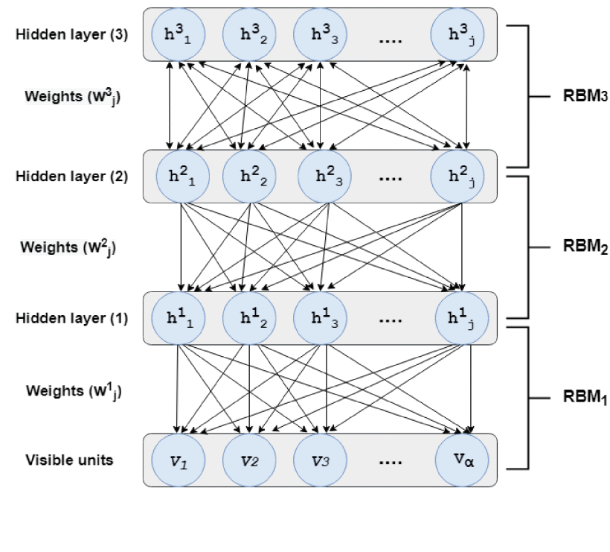

Fig. 1 Three Hidden Layer DBN

### **B. Long-Short Term Memory (LSTM)**

LSTM stands for Long Short-Term Memory, a distinctive variant within the family of Recurrent Neural Networks (RNNs). It was originally introduced by *Hochreiter and Schmidhuber (1997)* in their work. The fundamental building block of LSTM is a cell, which takes the place of the hidden layer neurons found in traditional RNNs. Each LSTM cell is primarily characterized by three crucial components or gates: the input, the output, and the forget gate, illustrated in the provided diagram.

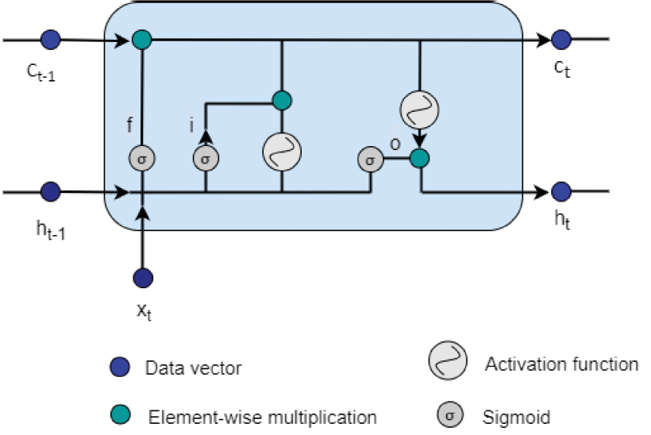

Fig.2 LSTM Memory Cell

### **C. Multilayer Perceptron With 6 Layers (MLP-6L)**

MLP, short for Multi-Layer Perceptron, is a method that is based on a feed-forward neural network, it is typically employed in supervised learning scenarios. It relies on back-propagation learning techniques, as outlined in *Kasgari, Divsalar, Javid, and Ebrahimian (2013)*. An MLP comprises a neural network structure with input and output layers, as well as one or more parallel layers that are hidden. The structure of the MLP is characterized by complete interconnections among its layers. However, when the number of layers that are hidden is increased, the MLP transitions from being a conventional learning approach to a deep learning method, as discussed in *Hatcher and Yu (2018)*. In our research, we have utilized an MLP model featuring four hidden layers, resulting in a total of six layers in the network. Consequently, we refer to this configuration as MLP-6L.

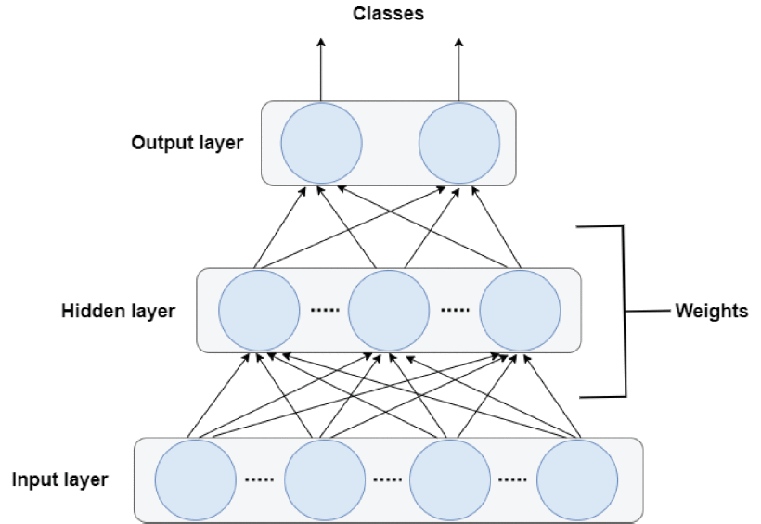

Fig.3 Three Layer MLP

In each layer, every processing unit establishes connections with all the units in the subsequent layer through weighted links, as described in *Tsai and Wu (2008)*. The input values serve as representations of the data that is passed forward through the network. The information after being processed within the units relies on both the input data and the weight assigned to each connection between input and hidden units. Likewise, the data generated by the output units is contingent on the values present in the units that are hidden and the weight assigned to each connection between hidden and output units, as detailed in *Tsai and Wu (2008).*

### **D. Random Forest (RF)**

Random forest (RF), is a classification technique introduced by *Breiman (2001)*, that operates by generating multiple decision trees from the initial dataset. Typically, these datasets are constructed using the bootstrapping method, and the individual trees are built employing the C4.5 algorithm, a well-established decision tree approach primarily rooted in concepts of entropy and information gain. The ultimate classification outcome produced by RF is determined through a majority vote among these constituent subtrees.

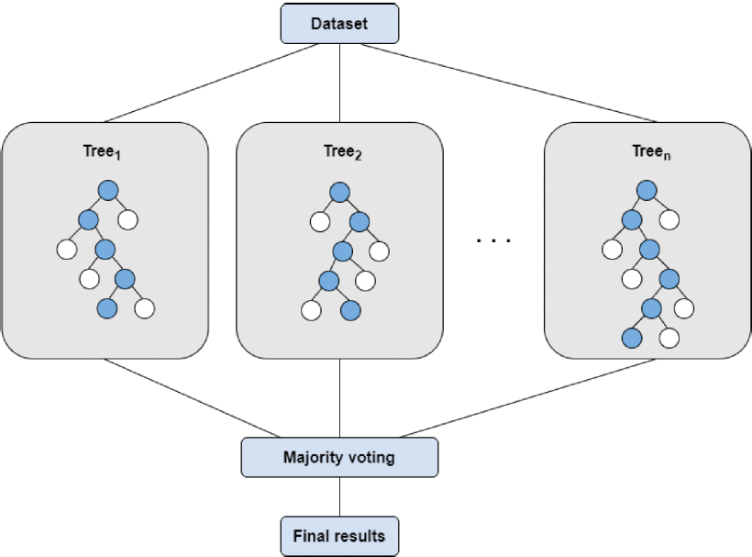

Fig.4 Structure of Random Forest

### **E. Support Vector Machine (SVM)**

SVM, short for Support Vector Machine, is a widely adopted supervised machine learning algorithm primarily designed for tackling binary classification and regression challenges. It was initially introduced by *Cortes and Vapnik (1995)*. In essence, SVM seeks to identify an optimal separating hyperplane in the feature space that maximizes the margin between the two classes. Importantly, the data doesn't necessarily need to be linearly separable. To simplify complex calculations in such cases, SVM employs kernel functions (including Linear, Gaussian Radial Basis function (RBF), Sigmoid, and Polynomial) as hyperparameters to determine the positioning of separating hyperplanes, as discussed in *Patle and Chouhan (2013).*

Furthermore, in our study, we leverage SVM as an ensemble model and apply bagging *Breiman (1996)* to enhance its classification performance. This involves utilizing the bootstrapping technique to generate multiple subsets from the original dataset and independently implementing the method multiple times. The outcomes of the ensemble model are aggregated through majority voting.

### **F. K-Nearest Neighbor (KNN)**

K-Nearest Neighbor (KNN), is another frequently employed non-parametric machine learning algorithm originally introduced by *Cover and Hart (1967)*. Its principle involves determining the class label of each sample based on its similarity to its nearest neighbors. *Chomboon, Chujai, Teerarassammee, Kerdprasop, and Kerdprasop (2015)* state that a variety of metrics which includes Mahalanobis or Euclidian or Hamming can be used to find resemblance in the samples.

To ensure clarity in the assignment of class labels and avoid ambiguity, the value of K (it represents the number of nearest neighbors considered) is typically an odd number. In our research, we propose using K-Nearest Neighbor as an ensemble method with the help of bagging techniques.

**G. Magnetic Optimization Algorithm - Particle Swarm Optimization (MOA-PSO)**

The Magnetic Optimization Algorithm (MOA) is a relatively recent heuristic optimization technique developed by *Tayarani-N and Akbarzadeh-T (2008)*. Research has demonstrated its effectiveness in tackling optimization problems, primarily those involving continuous real search spaces described in *Mirjalili and Sadiq (2011)*. On the other hand, Particle Swarm Optimization (PSO) is a widely recognized metaheuristic optimization approach that has been extensively explored for optimizing a wide range of problems across various domains as discussed in *Nakisa, Nazri, Rastgoo, and Abdullah (2014)*. Initially proposed by *Eberhart and Kennedy (1995)*, PSO has undergone several modifications over the years to enhance its performance.

In this study, we will work on the development and implementation of a neural network algorithm, named MOA-PSO. Artificial Neural Networks (ANNs) in the context of bankruptcy prediction. MOA-PSO leverages the local search capabilities of MOA and the social thinking capabilities of PSO. Our research aims to demonstrate the capability of ANNs to the other DL and ensemble methods being used in our research.

**DATASET CONSIDERED**

We have examined a dataset comprising Taiwanese companies, encompassing 6819 entries collected over a decade from 1999 to 2009. Among these entries, 6599 companies (approximately 97%) are non-bankrupt, while 220 companies (roughly 3%) are labeled as bankrupt. Clearly, the dataset exhibits significant class imbalance. It includes 95 financial health indicators and a single-class label indicating the bankruptcy status of each company. Detailed information about our dataset can be found in *Liang, Lu, Tsai & Shih (2016)*.

**METHODOLOGY**

1. The literature review on 'Company Bankruptcy prediction' involved a thorough investigation of existing research papers related to our chosen topic. We analyzed the various methodologies and evaluation techniques used by different authors in their studies.

2. Throughout history, numerous methods have been employed to predict company bankruptcy. However, many of these methods have become outdated as new financial challenges arise, necessitating the adoption of newer approaches. For our predictive model, we have deliberately opted to utilize Deep Learning (DL) methods and explore the potential of an Artificial Neural Network (ANN) hybrid model.

3. Selecting an appropriate dataset is a critical aspect of building our model, as its success hinges on the quality and relevance of the data. We managed to identify three company datasets from three different countries which were Poland, Taiwan, and Spain. After careful consideration, we chose the Taiwan Companies Dataset due to its greater volume of relevant studies and ease of comparison with our work.

4. Having finalized our dataset and methods, we can now proceed with the actual construction and training of our models.

5. The training process is of utmost importance but also time-consuming. We face the challenge of incorporating various probabilities and utilizing different methods to ensure our model's accuracy.

6. To assess the performance of our models, we plan to employ two evaluation methods. We will be using machine learning evaluation techniques to access the performance of our models which includes F1-score, precision, accuracy, and recall. Secondly, we will compare our machine-learning results with the findings from previous research.

7. All the methods, models, and conclusions will be summarized comprehensively in our findings. We will develop a detailed report, covering each step of the project, to provide a clear understanding of our research.

**SCHEDULE (18TH JUNE 2023 – 31ST DECEMBER 2023):**

1. Project Definition and Proposal Submission:

a. 18th June 2023 – 19th July 2023

b. Duration: 31 days

2. Literature Review:

a. 20th July 2023 – 5th August 2023

b. Duration: 16 days

3. Model Building and Training:

a. 6th August 2023 – 20th September 2023

b. Duration: 45 days

4. Performance Enhancement and Evaluation:

a. 21st September 2023 – 31st October 2023

b. Duration: 40 days

5. Final Findings and Dissertation Report:

a. 1st November 2023 – 31st December 2023

b. Duration: 60 days

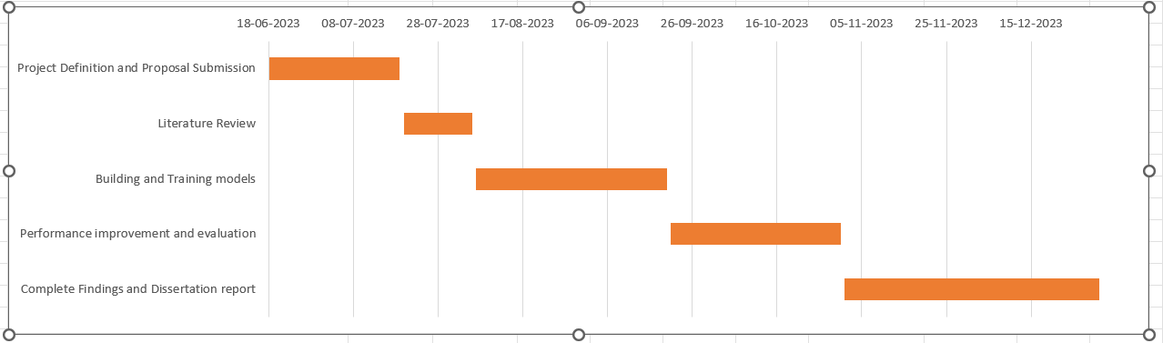

Fig. 5: Project Timeline

**RESOURCES AND BUDGET**

1. We require a comprehensive dataset containing the necessary financial indicators for our research, encompassing both bankrupt and non-bankrupt company data.

2. To facilitate the training process, we will utilize high-performance computing power, particularly a powerful GPU. This will significantly expedite the model training.

3. For the development of our models, we will use multiple different software and libraries which includes Python for development, google collab as our editor, and frameworks such as TensorFlow and Keras.

4. The Taiwan Company dataset which we will be referring to for our research is available to the public for free research and development.

5. To meet our higher computational powers requirements to develop and train our models, we will be accessing Kingston University's Library and computer facility.

**ETHICS, AND DATA PROTECTION**

• Our research relies on a publicly available Taiwan Company dataset, which has undergone extensive investigation by multiple authors using various machine learning methods.

• By using the Taiwan Company dataset which is available for free, we have made sure that we comply with the strict General Data Protection Regulation (GDPR) laws.

• The entirety of our models and research findings used from our academic work will be stored on a website called “BOX”.

• The Features of “BOX” will allow us to safeguard our data and findings as it will delete all the material stored in 6 months.

• We prioritize ethical considerations and are committed to utilizing the data responsibly, contributing positively to society through our research findings.

• Our intention is to use the data solely for research purposes, avoiding any misuse and instead, aiding future research endeavors.

**REFERENCES**

J. L. Bellovary, D. E. Giacomino and M. D. Akers (2007), "A review of bankruptcy prediction studies: 1930 to present", J. Financial Educ., vol. 33, pp. 1-42.

D. Veganzones and E. Séverin (2018), "An investigation of bankruptcy prediction in imbalanced datasets", Decis. Support Syst., vol. 112, pp. 111-124.

J. Schmidhuber (2015), "Deep learning in neural networks: An overview", Neural Netw., vol. 61, pp. 85-117.

Y. Jang, I.-B. Jeong, Y. K. Cho and Y. Ahn (2019), "Predicting business failure of construction contractors using long short-term memory recurrent neural network", J. Construct. Eng. Manage., vol. 145, no. 11.

T. Le, M. Lee, J. Park and S. Baik (2018), "Oversampling techniques for bankruptcy prediction: Novel features from a transaction dataset", Symmetry, vol. 10, no. 4, pp. 79.

Y. Jang, I. Jeong and Y. K. Cho (2020), "Business failure prediction of construction contractors using a LSTM RNN with accounting construction market and macroeconomic variables", J. Manage. Eng., vol. 36, no. 2.

E. Fedorova, E. Gilenko and S. Dovzhenko (2013), "Bankruptcy prediction for Russian companies: Application of combined classifiers", Expert Syst. Appl., vol. 40, no. 18, pp. 7285-7293.

G. E. Hinton, S. Osindero and Y.-W. The (2006), "A fast learning algorithm for deep belief nets", Neural Comput., vol. 18, no. 7, pp. 1527-1554.

A. A. Kasgari, M. Divsalar, M. R. Javid and S. J. Ebrahimian (2013), "Prediction of bankruptcy Iranian corporations through artificial neural network and probit-based analyses", Neural Comput. Appl., vol. 23, no. 3, pp. 927-936.

S. Hochreiter and J. Schmidhuber (1997), "Long short-term memory", Neural Comput., vol. 9, no. 8, pp. 1735-1780.

L. Breiman (1996), "Bagging predictors", Mach. Learn., vol. 24, no. 2, pp. 123-140.

L. Breiman (2001), "Random forests", Mach. Learn., vol. 45, no. 1, pp. 5-32.

C. Cortes and V. Vapnik (1995), "Support-vector networks", Mach. Learn., vol. 20, no. 3, pp. 273-297.

T. Cover and P. Hart (1967), "Nearest neighbor pattern classification", IEEE Trans. Inf. Theory, vol. IT-13, no. 1, pp. 21-27.

L. Zhou (2013), "Performance of corporate bankruptcy prediction models on imbalanced dataset: The effect of sampling methods", Knowl.-Based Syst., vol. 41, pp. 16-25.

S. S. Devi and Y. Radhika (2018), "A survey on machine learning and statistical techniques in bankruptcy prediction", Int. J. Mach. Learn. Comput., vol. 8, no. 2, pp. 133-139.

E. I. Altman (1968), "Financial ratios discriminant analysis and the prediction of corporate bankruptcy", J. Finance, vol. 23, no. 4, pp. 589-609.

J. A. Ohlson (1980), "Financial ratios and the probabilistic prediction of bankruptcy", J. Accounting Res., vol. 18, no. 1, pp. 109-131.

H. Aljawazneh, A. M. Mora, P. García-Sánchez and P. A. Castillo-Valdivieso (2021) "Comparing the Performance of Deep Learning Methods to Predict Companies’ Financial Failure," in IEEE Access, vol. 9, pp. 97010-97038, doi: 10.1109/ACCESS.2021.3093461.

Khurma, R.A.; Aljarah, I.; Sharieh, A.; Mirjalili, S. Evolopy-fs (2020) An open-source nature-inspired optimization framework in python for feature selection. In Evolutionary Machine Learning Techniques; Springer: Berlin/Heidelberg, Germany; pp. 131–173.

Cheng, R.; Jin, Y. (2014) A competitive swarm optimizer for large scale optimization. IEEE Trans. Cybern. **2014**, 45, 191–204.

Ansari, A.; Ahmad, I.S.; Bakar, A.A.; Yaakub, M.R (2020). A hybrid metaheuristic method in training artificial neural network for bankruptcy prediction. *IEEE Access*

Mahendru, K.; Garg, G.; Sharma, A.; Srivastava, R (2021) Evolutionary Methods for Bankruptcy Prediction: A Study on Indian Firms. In Soft Computing for Problem Solving; Springer: Berlin/Heidelberg, Germany; pp. 303–313.

Liang, D.; Lu, C.C.; Tsai, C.F.; Shih, G.A (2016) Financial ratios and corporate governance indicators in bankruptcy prediction: A comprehensive study. Eur. J. Oper. Res., 252, 561–572.

Al-Badarneh, I.; Habib, M.; Aljarah, I.; Faris, H. (2020) Neuro-evolutionary models for imbalanced classification problems. J. King Saud Univ. Comput. Inf. Sci., 34 (Pt A), 2787–2797.

J. Brozyna, G. Mentel and T. Pisula (2016), "Statistical methods of the bankruptcy prediction in the logistics sector in Poland and Slovakia", Transformations Bus. Econ., vol. 15, no. 1, pp. 80-96.

S. Jones and D. A. Hensher (2004), "Predicting firm financial distress: A mixed logit model", Accounting Rev., vol. 79, no. 4, pp. 1011-1038.

P. P. M. Pompe and A. J. Feelders (1997), "Using machine learning neural networks and statistics to predict corporate bankruptcy", Comput.-Aided Civil Infrastruct. Eng., vol. 12, no. 4, pp. 267-276.

J. Min and Y. Lee (2005), "Bankruptcy prediction using support vector machine with optimal choice of kernel function parameters", Expert Syst. Appl., vol. 28, no. 4, pp. 603-614.

S. R. Islam, W. Eberle, S. K. Ghafoor, S. C. Bundy, D. A. Talbert and A. Siraj (2019), "Investigating bankruptcy prediction models in the presence of extreme class imbalance and multiple stages of economy", arXiv:1911.09858.

F. J. L. Iturriaga and I. P. Sanz (2015), "Bankruptcy visualization and prediction using neural networks: A study of U.S. Commercial banks", Expert Syst. Appl., vol. 42, no. 6, pp. 2857-2869.

Z. Lanbouri and S. Achchab (2015), "A hybrid deep belief network approach for financial distress prediction", Proc. 10th Int. Conf. Intell. Syst. Theories Appl. (SITA), pp. 1-6.

M.-J. Kim, D.-K. Kang and H. B. Kim (2015), "Geometric mean based boosting algorithm with over-sampling to resolve data imbalance problem for bankruptcy prediction", Expert Syst. Appl., vol. 42, no. 3, pp. 1074-1082.

S.-H. Yeh, C.-J. Wang and M.-F. Tsai (2015), "Deep belief networks for predicting corporate defaults", Proc. 24th Wireless Opt. Commun. Conf. (WOCC), pp. 159-163.

T. Hosaka (2019), "Bankruptcy prediction using imaged financial ratios and convolutional neural networks", Expert Syst. Appl., vol. 117, pp. 287-299.

W. G. Hatcher and W. Yu (2018), "A survey of deep learning: Platforms applications and emerging research trends", IEEE Access, vol. 6, pp. 24411-24432.

C. Tsai and J. Wu (2008), "Using neural network ensembles for bankruptcy prediction and credit scoring", Expert Syst. Appl., vol. 34, no. 4, pp. 2639-2649.

A. Patle and D. S. Chouhan (2013), "SVM kernel functions for classification", Proc. Int. Conf. Adv. Technol. Eng. (ICATE), pp. 1-9.

K. Chomboon, P. Chujai, P. Teerarassammee, K. Kerdprasop and N. Kerdprasop (2015), "An empirical study of distance metrics for k-nearest neighbor algorithm", Proc. 2nd Int. Conf. Ind. Appl. Eng., pp. 280-285.

M. H. Tayarani-N and M. R. Akbarzadeh-T (2008), "Magnetic optimization algorithms a new synthesis", Proc. IEEE Congr. Evol. Comput. (IEEE World Congr. Comput. Intell.), pp. 2659-2664.

M.-H. Tayarani-N and M.-R. Akbarzadeh-T (2014), "Magnetic-inspired optimization algorithms: Operators and structures", Swarm Evol. Comput., vol. 19, pp. 82-101.

S. Mirjalili and A. S. Sadiq (2011), "Magnetic optimization algorithm for training multi layer perceptron", Proc. IEEE 3rd Int. Conf. Commun. Softw. Netw., pp. 42-46.

B. Nakisa, M. Z. A. Nazri, M. N. Rastgoo and S. Abdullah (2014), "A survey: Particle swarm optimization based algorithms to solve premature convergence problem", J. Comput. Sci., vol. 10, no. 9, pp. 1758-1765.

V. Beiranvand, M. Mobasher-Kashani and A. A. Bakar (2014), " Multi-objective PSO algorithm for mining numerical association rules without a priori discretization ", Expert Syst. Appl., vol. 41, no. 9, pp. 4259-4273.

R. Eberhart and J. Kennedy (1995), "A new optimizer using particle swarm theory", Proc. MHS. Proc. 6th Int. Symp. Micro Mach. Hum. Sci., pp. 39-43.